**Loading Data Into HBase Using PIG Scripts**

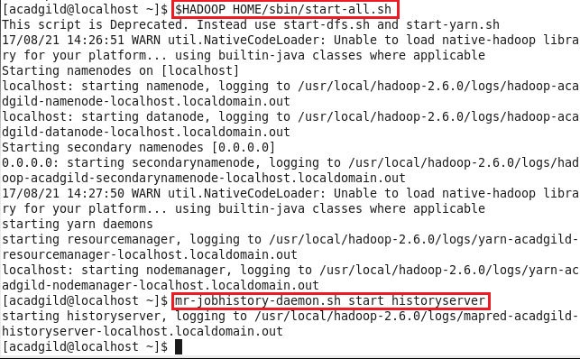**Step 1: Starting hadoop daemons and job history server using below commands**

**Step 2: Starting hbase daemons using below command, and checking using jps whether all required daemons have started or not**

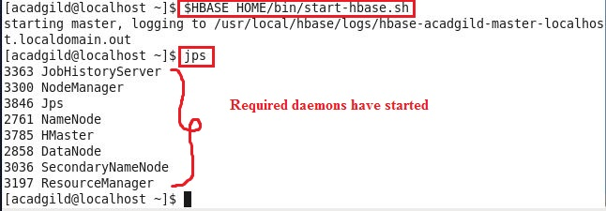

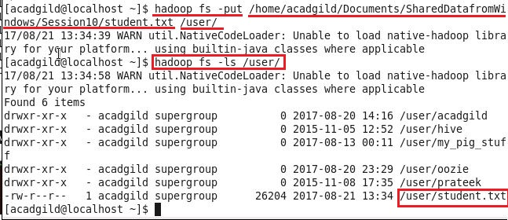**Step 3: Copying the data set “student.txt” into HDFS which will further be loaded into HBase**

**Below screenshot shows that data has been loaded successfully in hdfs:**

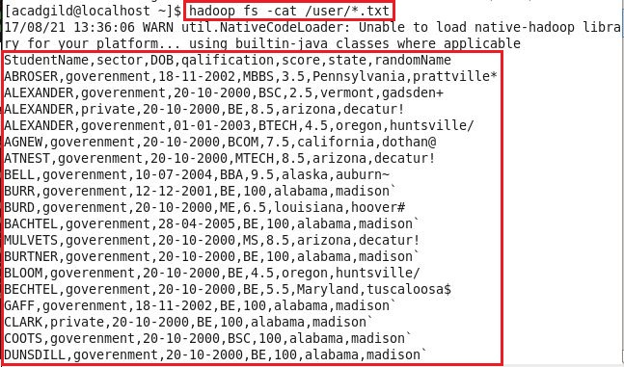

**Step 4: Including few jar files of HBase to the Pig classpath**

**G:\ACADGILD\course material\Hadoop\Sessions\Session 10\Assignments\Assignment2\Screenshots\8.JPG**

**Step 5:** **Starting HBase shell and creating a table “studentAcad”**

**We only need this table as skeleton so PIG can store data inside this by referring the table name.**

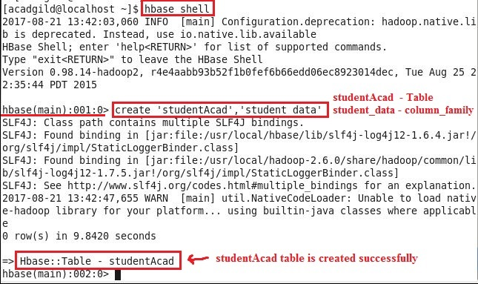

**Using describe command, we can check schema of “studentAcad” table**

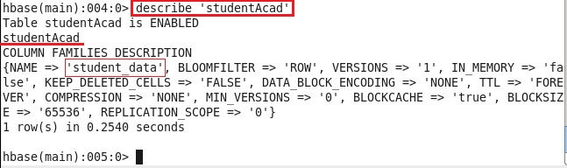

**Step 6: Starting PIG in mapreduce mode**

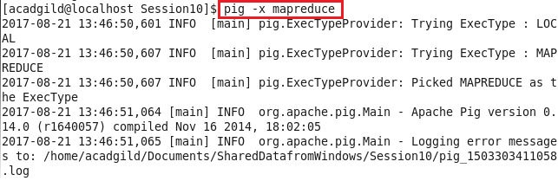

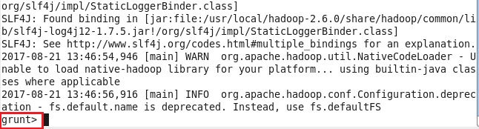

**Step 7: As** **we are inside PIG grunt shell, so loading data from HDFS to Alias relation**

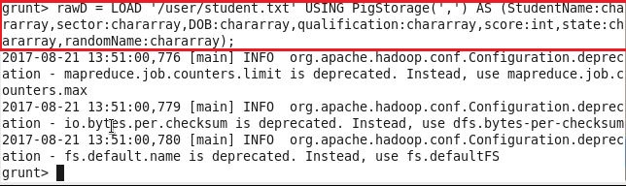

**Step 8: Now transferring the data inside HBase by STORE command**

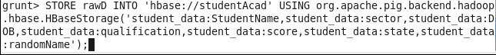**We need to ensure that we give the correct name for table name created inside HBase. Also the parameters should be kept in mind to avoid mistake.**

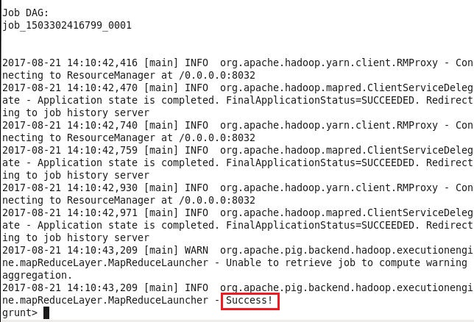**Once the success message comes as shown below, it is confirmed our data is loaded inside HBase.**

**Step 9: The result can be displayed through scan command followed by table name inside quotes ( ‘ ’ )**

**G:\ACADGILD\course material\Hadoop\Sessions\Session 10\Assignments\Assignment2\Screenshots\c.JPG**

